Step 1: Define the Change
"Leadership is not about being in charge. It's about taking care of those in your charge."
— Simon Sinek
"The best way to predict the future is to create it."
— Abraham Lincoln

Objective:
In step one, Prepare for Change, we will focus on defining the purpose, scope, and goals of the change. It's crucial to understand the "why" behind the change and establish a clear vision for success.


Prepare for Change
The first step in Change Management is getting the organization ready for what’s coming. This means figuring out if everyone’s on board, setting clear goals for the change, and coming up with a solid plan.
This step is super important because if you don’t prep properly, you could run into resistance, confusion, or misalignment with the bigger goals. When done right, it lays a strong foundation, making sure everyone understands why the change is happening and what to expect. Without proper preparation, though, things can get messy, people might not be on the same page, and employees might not be fully committed, which could hinder the whole change process.
Alright, let’s dive into a change you’d love to see in your team, department, or organization! Grab a pen and let’s get started with Exercise 1.1: Identify the Need for Change below – it's time to shake things up!

Exercise 1.1: Identify the Need for Change
Purpose: Get to the bottom of why this change is needed.
Instructions:
Jot down why this change is happening in your organization. Think about the issues or opportunities that sparked this decision.

- Use these questions to help you figure out what’s driving the change:
Is the market pushing us in this direction?
Do we need to improve processes or make things more efficient?
Are we introducing new tech or ways of working?
What problems are we solving, and what opportunities are we grabbing?
Reflection Questions:
Why is now the right time for this change?
How will this change benefit the team or organization?
Alright, now that we’ve nailed down why change is needed, let’s have some fun imagining what things will look like once it’s all wrapped up! Take a minute to dive into Exercise 1.2: Set Clear Objectives and start picturing that awesome end result for your change plan.
Let’s make it happen!
Exercise 1.2: Set Clear Objectives
Purpose: Define what success looks like for this change.
Instructions:
- Write down exactly what you want to achieve with this change.
- Make sure these objectives align with the bigger picture of the organization's overall goals and strategy.
- Review the Workforce Scenario to assist with answering your change management SMART goals.
WORKFORCE SCENARIO:
Morgan, the leader, has been struggling with overburdening herself with tasks that could easily be delegated. She has recognized that the team members are capable but have not been given opportunities to develop or demonstrate their abilities. Morgan decides to focus on cultural change—learning to delegate and trust her team.
SMART Goal Framework (Specific, Measurable, Achievable, Relevant, Time-bound)
Specific: Morgan will delegate at least 5 tasks each week to different team members to help them develop their skills.
- Why it matters: Clearly defined tasks for delegation ensure that Morgan is actively distributing work and providing opportunities for growth.
Measurable: Ensure that at least 80% of team members report feeling more empowered and confident in their roles after 6 weeks.
- Why it matters: By gathering feedback, Morgan can measure whether her delegation is having a positive impact on her team’s confidence and development.
Achievable: Morgan will hold a 30-minute meeting each week to guide and support team members with the tasks they’ve been delegated.
- Why it matters: This goal is attainable and ensures that Morgan remains actively involved in the development process without micromanaging.
Relevant: Align the change with the team’s growth goals, ensuring that Morgan’s leadership style supports individual development and contributes to improved team performance over the next quarter.
- Why it matters: This ensures the change is in line with the team’s personal and professional growth, which will ultimately lead to better results.
Time-bound: By the end of the next month, Morgan will have fully delegated at least 20 tasks, and the team will have had time to reflect on how the new approach has helped them grow.
- Why it matters: The timeline gives Morgan a clear deadline and allows for tracking progress toward more balanced leadership and empowered team members.

Specific:

Measurable:

Achievable:

Relevant:

Time-bound:

Reflection Questions:
Are the objectives clear and measurable?
How do these objectives fit into the organization's bigger strategy?
Nice job! Now, let’s ask ourselves an important question: Are YOU ready to lead this change? Take a look at the readiness assessment below and simply check yes or no to the questions. Let’s see if you’re all set to take the lead!

Readiness Assessment for Leaders
For Leaders:
- I have clearly defined the purpose and vision for the change.
Yes ☐ No ☐
- I can articulate the expected outcomes and how they align organizational goals.
Yes ☐ No ☐
- I am prepared to answer "why" the change is necessary and communicate its value.
Yes ☐ No ☐
- I have identified the specific goals and success metrics for the change.
Yes ☐ No ☐
- I have addressed potential concerns about the change and am ready to discuss them openly.
Yes ☐ No ☐

No pressure—there’s no wrong answer here! This assessment is just a way to make sure you're kicking off the change management plan on the right foot. If you’ve answered "no" to any of the questions, no worries! Check out our Resources for Leaders and the Podcast links for some extra support. You’ve got this!
If you’ve checked "yes" to all of the questions, awesome! Now it’s time for a bit of self-reflection. A successful change management plan is all about balancing process and interpersonal skills. Below are the key behaviors leaders should focus on during this stage to really make the plan shine. These behaviors are like the secret sauce for making change work!
Take a look and see where you’re at!

Key Behaviors for Leaders to Cultivate:
Clarity and Transparency: It’s all about being clear! Leaders need to openly communicate why the change is happening and what the goals are. Do you encourage questions, keep consistent messaging and are open to feedback?
Visionary Thinking: Leaders should paint a picture of what the future looks like after the change—make it exciting and easy to imagine! Do you plan for the long term, seek creative ways to improve and inspire your team with a sense of purpose?
Ownership and Accountability: It’s important that everyone knows their role and feels responsible for the results. Leaders should set the tone for accountability and ensure the team is on the same page. Are you delegating tasks and projects clearly, setting clear expectations, empowering your team to make decisions and role modeling accountability?
Woo-hoo! Let’s keep the momentum going! It’s time to rally the team and get everyone aligned. Grab the whiteboard, snacks, and let’s dive into the change process! Ready to discuss goals, share ideas, and get everyone on the same page?

Below are some helpful tips on how to manage the team meeting and an example dialogue from the Workforce Scenario. Once you feel comfortable it’s time to set a meeting with your team about how we’re going to crush this change together! 👊✨

Setting the Stage:
- Start with the Why
Before diving into the specifics of the change, help everyone understand why this change is happening. Be open and transparent about the reasons behind the change—whether it’s driven by external factors (like market shifts) or internal needs (like improving efficiency). People are more likely to buy into the process if they see the bigger picture.
2. Keep it Positive & Solution-Focused
Change can feel intimidating, so focus on the opportunities rather than just the challenges. Talk about the benefits this change will bring to both the team and the company. It’s about showing them that this change isn’t something to fear, but something that can make their work easier or more rewarding.
3. Be Transparent About What’s Coming
Don’t leave people in the dark. Share clear details about what’s going to happen next. What’s the timeline? How will their work be affected? This helps everyone mentally prepare and reduces uncertainty. Plus, people appreciate knowing exactly what to expect.
4. Encourage Open Dialogue
A successful meeting isn’t a one-way street. Invite feedback and questions. Create a space where team members can voice their concerns or suggestions. Be ready to listen, validate their thoughts, and address any worries. This helps build trust and shows that you value their input.
5. Emphasize the Importance of Collaboration
Make sure everyone knows that this change isn’t a “top-down” initiative—it’s a team effort. Get their buy-in by framing it as a collective journey. Encourage collaboration throughout the process. Teamwork makes the dream work, right?
6. Set Clear Expectations
It’s important to set expectations for the team and make sure they understand their roles in the change process. Whether it’s adopting new tools, learning new skills, or changing their processes, make sure each person knows how they’ll contribute to the success of the plan.
7. Stay Positive, even if Resistance Comes Up
Not everyone will be immediately on board with the change, and that’s okay. If you encounter resistance or hesitation, stay calm and positive. Be empathetic, and address concerns with understanding. Acknowledge the discomfort but redirect the conversation toward the bigger picture and the benefits.
8. End with Action Steps

Leave the meeting with everyone knowing what the next steps are. Whether it’s scheduling follow-up meetings, starting training, or working on specific tasks, make sure everyone walks away with clarity about what comes next and how they fit into the process.
Bonus Tip: Use Visuals and Stories When explaining the need for change, stories, and visuals can make a huge difference. Share a story or case study about how similar changes have positively impacted others easier to digest and keep the energy high in the room.
Be empathetic, and address concerns with understanding. Acknowledge the DISCOMFORT, BUT redirect the conversation toward the bigger picture and the benefits.

WORKFORCE SCENARIO:
Dialogue:
Morgan (Leader):
"Team, I’ve realized that I’ve been doing too much of the work myself, and I need to change that. I’m going to start focusing more on leadership, guidance, and support, and I need your help to do so. This means I’ll be delegating more tasks to you so that you can grow and develop your skills."
Ben (Team Member 1):
"Honestly, Morgan, I’ve noticed you often take on tasks that I could be doing. I feel like I’m not growing when you handle things for me."
Maria (Team Member 2):
"I agree. I’ve been here long enough to take on more responsibility, but I feel like my role hasn’t really expanded because you’re always stepping in."
Tom (Team Member 3):
"I’m excited for the opportunity to learn and take on more, but I need guidance on how to handle tasks and how to do them properly."
Morgan (Leader):
"I hear you, and I appreciate your honesty. I’ve realized that by doing everything myself, I’ve been holding you back from the development opportunities you deserve. Going forward, I will focus on delegating tasks and providing the support you need to succeed."

Now that you’ve had your team meeting it’s time to dive into the readiness assessment to get a clearer picture of how ready your team truly is. This helps identify areas where they may need additional support or where they’re already in sync with the change plan.

Post Meeting Readiness Assessment!
1. Check for Buy-In
Do your team members seem open to the change?
( If they were asking thoughtful questions, engaging in the conversation, and showing interest in understanding how it will affect their day-to-day, that's a good sign)
Yes ☐ No ☐
Do they express excitement or optimism?
(It’s important to see if they’re looking forward to the new possibilities or if they're feeling skeptical.)
Yes ☐ No ☐
- Look for Resistance
Were there any signs of resistance?
(Look out for team members who seem withdrawn, confused, or hesitant. These are signs that they might need more support or clarification.)
Yes ☐ No ☐
Are there any lingering concerns?
(Did people express doubt about the feasibility of the plan or the outcomes? Address these concerns early on to prevent bigger issues down the line.)
Yes ☐ No ☐
- Assess Their Understanding of Their Role
Does everyone understand their part in the change?
(Did they walk away from the meeting knowing exactly how their actions fit into the change process? Clear roles are crucial for a successful transition.)
Yes ☐ No ☐
Were action steps discussed?
( A strong readiness means team members should have walked away knowing their next steps and feeling confident about them.)
Yes ☐ No ☐
4. Gauge Emotional Readiness
How are people feeling about the process overall?
(It’s not just about their readiness to perform tasks but also how they feel about the journey. Are they motivated to embrace the change, or do they need more encouragement to get on board?)
Yes ☐ No ☐
5. Measure Willingness to Adapt
Is the team open to learning?
(Do they seem willing to adopt new processes, tools, or mindsets? This will be a critical factor in ensuring the change sticks in the long term.)
Yes ☐ No ☐
Are there any immediate action steps needed to get them ready?
(If team members need further training or clarity, it’s good to plan those next steps.)
Yes ☐ No ☐
Now's the perfect time to adjust your approach if needed, whether it’s additional communication, training, or motivational support. Keeping track of how the team feels helps ensure a smoother change process overall!

Below are a few behaviors to watch for in your team that might mean there’s still some work to do before moving on to the next step in the change management process. Keep an eye on these signs – they can help you figure out where extra support is needed!

Warning Signs for Leaders
Team Behaviors to Watch For:
Resistance to Change: When team members aren’t on board or actively push back against the change, it’s often because they don’t fully understand or agree with it.
Lack of Involvement: If your team isn’t involved in shaping the change or doesn’t see where they fit in the process, they might feel disconnected and less invested.
Uncertainty or Ambiguity: If team members are unclear on why the change is happening or how it affects them, it can lead to confusion, disengagement, or even resistance.
If you notice any of these behaviors in your team, it’s time to ask yourself a few important questions:

Is the change management plan lacking a clear vision? If you can’t clearly explain the purpose and goals of the change, the team will have a tough time understanding and getting on board.
Are you overlooking stakeholder needs? Ignoring the concerns of key stakeholders early on can lead to resistance down the road.
Are your expectations realistic? Setting super high expectations without factoring in resources and capabilities can cause frustration and disengagement.
Have you communicated well? If the change hasn’t been communicated properly, confusion, disengagement, or resistance might start creeping in.

A team that’s ready to rock and roll with change will show these awesome traits:

Green Flags for Team Members

Ask Questions and Seek Clarity:
They get involved and ask questions to really understand how the change will work.
Example: "Hey, how will this change affect my day-to-day tasks?"

Offer Input and Feedback:
They’re not just sitting back—they actively contribute ideas and feedback on how to make the change better.
Example: "I’ve got some thoughts on how we can improve this!"
Align Personal Goals with the Vision:
They think about how the change fits with their own personal goals, helping them stay motivated and aligned with the bigger picture.

Here are some fun and engaging activities to keep your team excited and involved during the change process.
Check out our team budling activities below!

Team Building Activities and Learning Activities:
- Vision Board Creation
  - Description: Teams work together to create a vision board that visualizes the goals of the change initiative. This helps participants clarify the vision and understand the shared objectives.
  - Directions: Provide materials such as magazines, scissors, glue, and markers. Ask participants to cut out images or write words that represent the vision of the change. Then, have the team discuss each element and how it aligns with the goals.
  - Vision Board Activity Guide (TBD)
- SMART Goals Setting
  - Description: Have the team collaboratively set SMART goals (Specific, Measurable, Achievable, Relevant, Time-bound) that align with the change.
  - Directions: Provide each team member with a worksheet to outline a SMART goal related to the change. Afterward, discuss the goals as a group and ensure they are clear and actionable.
  - SMART Goals Activity Template (TBD)
Learner Activities:
- SWOT Analysis
  - Description: Teams analyze the Strengths, Weaknesses, Opportunities, and Threats of the proposed change. This encourages critical thinking and clarity on why the change is necessary.
  - Directions: Provide a SWOT template and ask each team member to fill it out individually. Then, consolidate their responses into a group discussion to evaluate the change.
  - SWOT Analysis Template (TBD)
Strategies, Mapping Tools, and Forms
Strategies:
- Clear Vision and Goals: Establish a clear and compelling vision. Ensure everyone understands why the change is necessary and the desired outcomes.
- Leadership Alignment: Ensure all leaders are aligned with the change vision.
- Stakeholder Mapping: Identify key stakeholders and how the change will affect them. (TBD)
Mapping Tools:
- Stakeholder Analysis Matrix: A tool to identify and map stakeholders' influence, support, and resistance levels. (TBD)
- SWOT Analysis (Strengths, Weaknesses, Opportunities, Threats): To evaluate the organization’s readiness for change.
Forms:
- Change Request Form: Used to formally request and document the reason for the change. (TBD)
- Vision Statement Template: A simple template to communicate the vision and objectives of the change. (TBD)
Alright, let’s dive into how Morgan’s SWOT analysis is shaping up with the team! Ready to see what’s working, what needs a little tweaking, and what could shake things up for the better? Let’s go! 🎉

WORKFORCE SCENARIO: SWOT Analysis
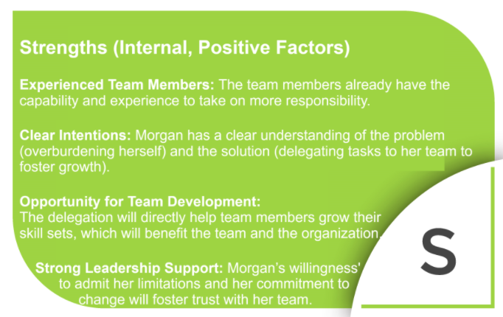
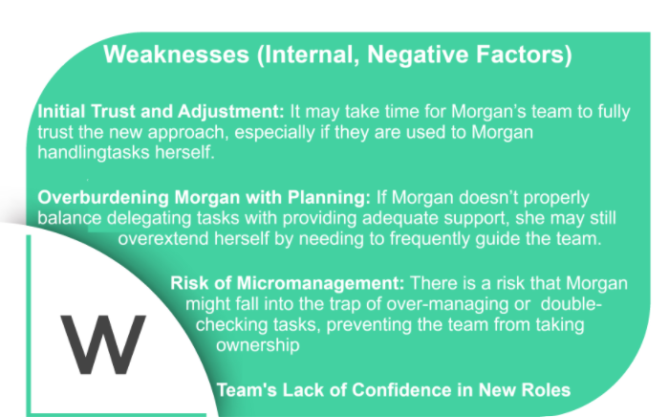

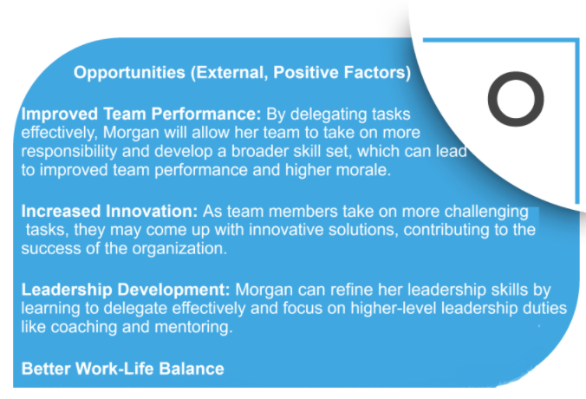
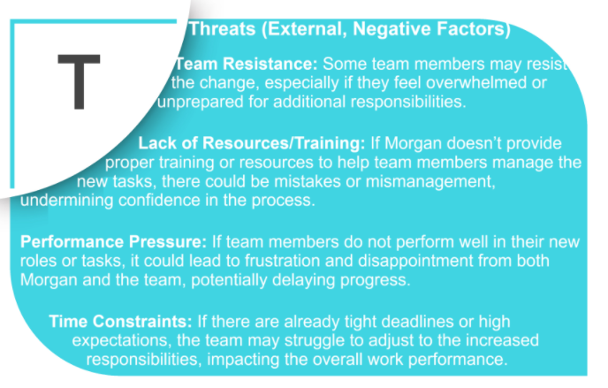
SWOT Summary in a nutshell: The team has some solid strengths with experience, clear leadership intentions, and a real opportunity for growth. But there are also weaknesses to keep in mind, like trust-building challenges, Morgan taking on too much planning work, and the risk of micromanaging—these need to be managed carefully. As for opportunities, there’s room to boost team performance, spark innovation, and develop leadership skills, all of which could benefit the organization. However, there are some threats to watch out for, such as potential team resistance, resource limitations, and performance pressures. By addressing these factors early on, Morgan can set up a much smoother and more successful change process for everyone.
Here are some awesome resources to help you and your team stay on track with the change management process:

Resources for Leaders and Team Members
For Leaders:
- Article: How to Define Change Management Goals
- Video: Defining Change Management | LinkedIn Learning
For Team Members:
- Article: TBD
- Video: TBD

Podcasts for Defining the Change
- Podcast: The Change Management Review Podcast
  - Insight: Provides expert interviews and discussions on defining and shaping organizational change, with a focus on leadership alignment and understanding the "why" behind change.
- Podcast: The Leadership Podcast
  - Insight: Offers insights into leadership strategies, helping leaders define and articulate the vision for change within their teams and organizations.
Fantastic! Before moving on to the next step, let's make sure you and your team are 100% clear on the change you're working toward. Use this checklist to ensure you've properly communicated everything so far:
Checklist for Defining the Change
Objective: Clearly articulate the purpose, scope, and goals of the change.
- Have you clearly defined the reason for the change?
Yes ☐ No ☐
- Is the vision for the future state articulated and easy to understand?
Yes ☐ No ☐
- Are the objectives of the change measurable and aligned with organizational goals?
Yes ☐ No ☐
- Have you identified the key outcomes and success metrics for the change?
Yes ☐ No ☐
- Have you considered the potential impact on employees, processes, and systems?
Yes ☐ No ☐
- Does your team see the value in the plan and demonstrate support?
Yes ☐ No ☐
Nice job! If you checked any "No's," don’t worry—you're definitely not alone in this! Change takes time, and it's totally normal to need a little extra work to make sure everything is crystal clear. The Workforce Development team is here to support you every step of the way, so don't hesitate to reach out if you need help. We got this!
Now, if you checked all yes’s—high five! 🙌 That means you're in a great spot to move forward. Step 2 is waiting, and you’re ready to dive in!
Let’s keep this momentum going and continue rocking the change process! 🌟

Section one of the workbook can be used as a practical guide for both leaders and team members to define and communicate the change effectively.

